**PROJECT EXECUTION STEPS**

Coder blog is a web based application can be executed by following steps:

* Install latest version of xampp server and complete set up.
* To run the code at first start apache server and MySQL modules of xampp server.

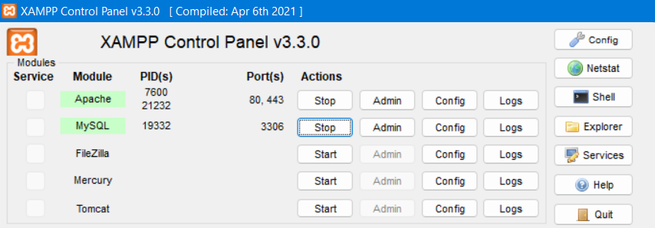

* Place the given code in C:\xampp\htdocs folder.

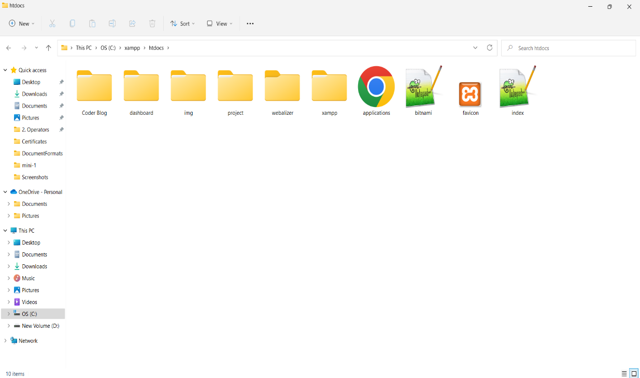

* Now go to PhpMyAdmin and create a database called coderblog.
* Now import the given coderblog.sql file in the code to create tables in database.

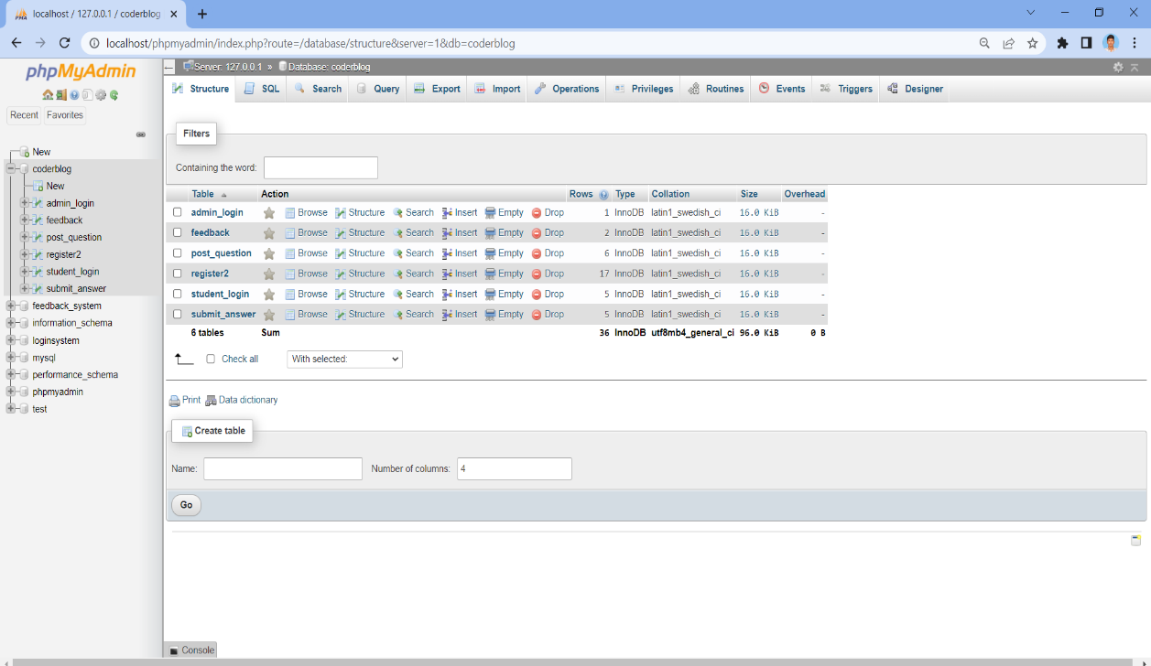

* Now open browser and type url as localhost/Coderblog/
* After loading of url the home page of the project is displayed as below.

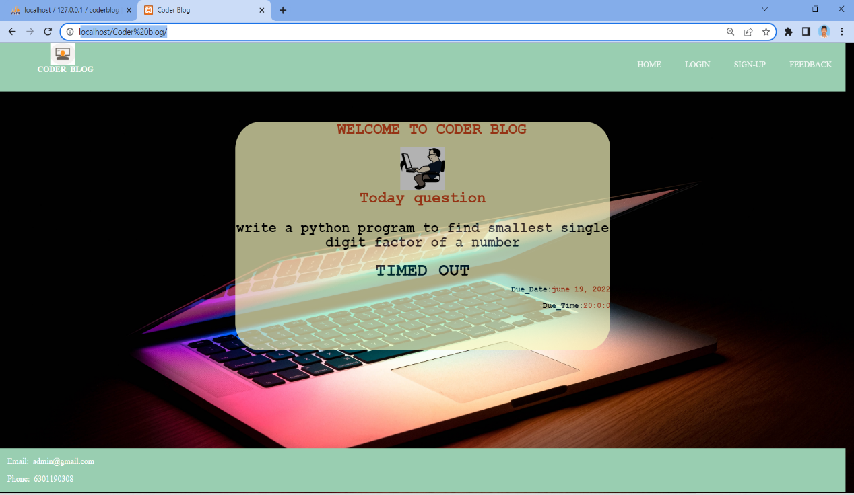

* In the above specified way coder blog project is executed.